The Father Drew Christiansen Lecture Series

The Catholic Advisory Council is an initiative of Churches for Middle East Peace. It was formed in 2021 under the direction of CMEP Board Member, and former Director of the U.S. Bishops’ Office of International Justice and Peace, Fr. Drew Christiansen, S.J.

Our purpose is to raise awareness in U.S. Catholic communities of our fellow Catholics and the Catholic Church’s presence in the Holy Land. We work in support of the political and socio-economic conditions that favor the permanence of Christians in the Holy Land, and we engage in advocacy and education to promote U.S. policies toward a just and lasting peace.

We fulfill this by promoting CMEP’s work within U.S. Catholic communities, and by providing Catholic based resources to foster greater Catholic engagement on the issue of peace with justice in the Holy Land.

To learn more about our work or to become involved please contact: Sir Jeffery Abood, KGCHS, Chair, Catholic Advisory Council at jabood@att.net

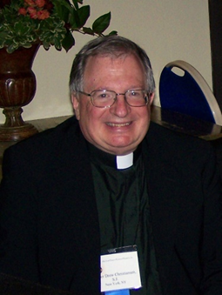
The Fr. Drew Christiansen Lecture Series - In 2022, CMEP began a lecture series named in honor of Fr. Drew Christiansen, S.J. Through this series our speakers provide a deeper understanding of how we can assist our brothers and sisters in their quest for acceptance, equality, justice, and peace. We explore the spiritual roots and practical application of our Faith through the eyes of those whose experience is rooted in the Land Jesus was born, taught, died, and was resurrected.

Previous Speakers:

His Beatitude Michel Sabbah, Latin Patriarch Emeritus of Jerusalem
Mr. Sami El-Yousef, CEO, Latin Patriarchate of Jerusalem
Sir Jeffery Abood, Knight Grand Cross of the Holy Sepulchre of Jerusalem
Dr. Bernard Sabella, Executive Director, Department of Service to Palestinian Refugees, Middle East Council of Churches
Dr. Rima Salah, Member, United Nations High-Level Independent Panel on Peace Operations, Deputy Special Representative of the Secretary-General, former Deputy Executive Director for UNICEF
Fr. David Neuhaus, SJ, Patriarchal Vicar for Hebrew-speaking Catholics in Jerusalem and Coordinator of the Pastoral Care for Migrant Workers and Asylum Seekers.

Previous and/or current Co-Sponsors of the Fr. Drew Christiansen Lecture Series


Bethlehem University Foundation (BUF) supports Palestinian students through scholarships to Bethlehem University, the only Catholic university in the Holy Land. Founded in 1973 by the Vatican following Pope Paul VI's historic 1964 visit to the Holy Land, the University serves more than 3,300 students in health sciences, business, engineering, and more. As an institutional anchor in the West Bank, Bethlehem University is vital to the region's social and economic vitality and to the preservation of its Christian presence. BUF is the university's U.S. philanthropic partner, opening a way for Americans to build the future with young adult Palestinians.

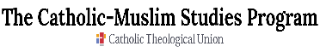
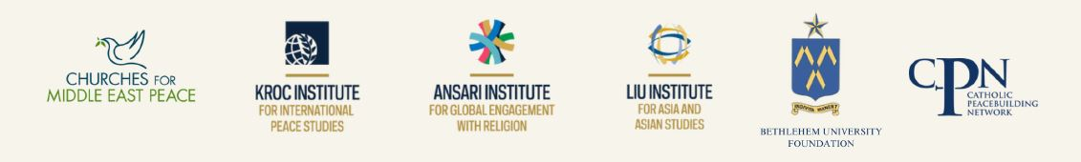

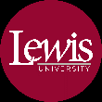
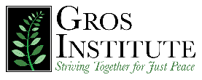
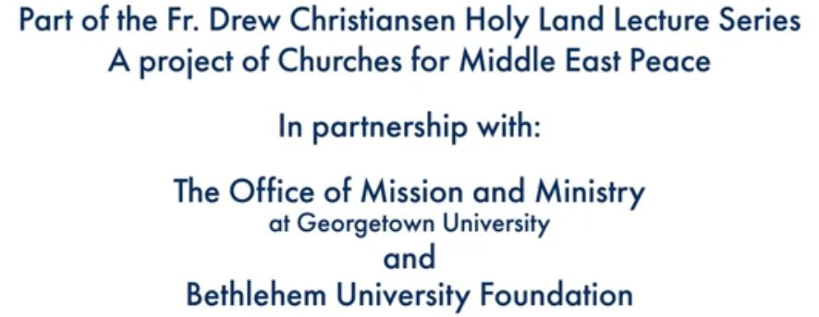
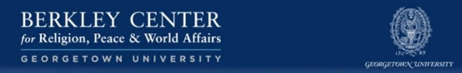

Links to previous Fr. Drew Lectures:
2022 – Mr. Sami El-Yousef, CEO Latin Patriarchate of Jerusalem
Being Church in the Land Called Holy
Dahlgren Chapel, Georgetown University - https://www.youtube.com/watch?v=KfcGGbTrDE8
2023 – Sir Jeffery Abood, KGCHS
The Church in the Holy Land and the Quest for Dignity
https://ansari.nd.edu/news-events/events/2023/09/18/fr-drew-christiansen-sj-lectures-the-church-in-the-holy-land-and-the-quest-for-human-dignity/
2023 - Dr. Bernard Sabella, Middle East Council of Churches
Israel-Palestine: Recent Developments, Difficulties Ahead
https://www.youtube.com/watch?v=PeN_Ixu3t6s
2024 – Dr. Rima Salah, UNICEF/United Nations
Exploring the Contributions of Women toward Peace, Dignity and Justice in the Holy Land
https://ansari.nd.edu/news-events/events/2024/10/09/fr-drew-christiansen-sj-lectures-exploring-the-contributions-of-women-toward-peace-dignity-and-justice-in-the-holy-land/
2025 – Fr. David Neuhaus, SJ
Equality, Justice, and Peace - A Catholic Vision for Reconciliation in Israel/Palestine Today

Berkley Forum - The Holy Land: The Place Jesus Never Left
https://berkleycenter.georgetown.edu/responses/the-holy-land-the-place-jesus-never-left

